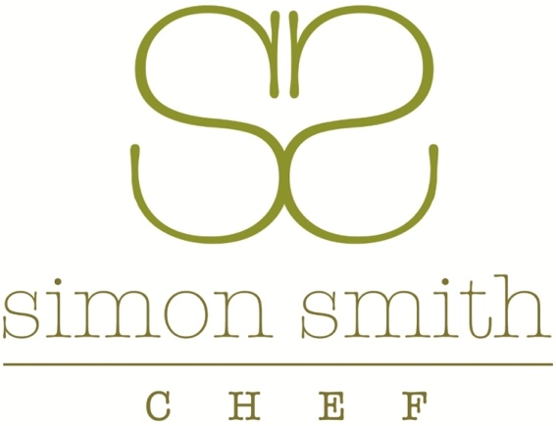
PRIVATE DINING MENU SELECTOR

A SELECTION OF CANAPÉS (YOU WILL BE SERVED ALL OF THESE OR SOMETHING SIMILAR)
CHERRY TOMATO AND MOZZARELLA PIPETTES WITH BALSAMIC AND OLIVE OIL (V)
SHROPSHIRE BLUE PATÉ ROLLED IN PECAN AND CHIVE, SERVED IN A CROUSTADE (V)
WARM VOL-AU-VENT OF ARTICHOKE, TRUFFLE AND PEA
GOAT’S CHEESE AND BEETROOT SERVED IN A BEETROOT WRAP (V)
SMOKED SALMON, CREAM CHEESE ON A RICE CRACKER
TO START
COLD POACHED FILLET OF SALMON WITH A WATERCRESS AND GINGER COULIS
MOROCCAN STYLE LAMB KEBAB WITH APRICOTS, ALMONDS, RAS EL HANOUT ON A POMEGRANATE AND YOGHURT COULIS
SALMON MARINATED WITH CITRUS, DILL, AND MUSTARD. SERVED WITH A CELERY SALT SCONE AND WATERCRESS
PANNA COTTA OF GOAT’S CHEESE WITH BEETROOT CARPACCIO AND PICKLED WALNUTS (V)
TERRINE OF PRESSED GAMMON HOCK AND PEAS WITH PICCALILLI AND PEA SHOOTS, GRAIN MUSTARD DRESSING
TUNA STEAK WITH A NIÇOISE TARTLET AND BASIL OIL DRESSING
SMOKED CHICKEN AND LIME PATÉ WITH TOASTED CIABBATTA
CRAB AND POTATO SALAD WITH A SEAWEED MAYONNAISE AND PICKLED RADISH
CAESAR SALAD OF ROAST CHICKEN WITH ROMAINE HEARTS, BURFORD BROWN EGG, BLUE CHEESE DRESSING, FRESH ANCHOVY AND FOCACCIA CROUTONS
POTTED DUCK WITH A HAZELNUT AND ORANGE SALAD, TOASTED BRIOCHE
SALAD OF PARMA HAM, MELON, FRESH FIG AND MOZZARELLA
ROAST CAULIFLOWER SOUP WITH STILTON CROUTONS (OR ANY SOUP YOU MAY WISH)
FILLET OF HOME SMOKED TROUT WITH CELERIAC SLAW, PEA VINAIGRETTE
SAUTÉED KING PRAWNS WITH A TOUCH OF CHILLI, GINGER AND COCONUT
BAKED FIG TART WITH HONEY AND MOZZARELLA (V)
MAIN COURSES
FILLET OF PORK STUFFED WITH WILD MUSHROOMS, SAGE AND PANCETTA, SERVED WITH BAKED MACARONI AND TALLEGIO CHEESE
BREAST OF CORN FED CHICKEN WITH FRESH TARRAGON, CHESTNUT MUSHROOMS AND A CREAM SAUCE
FILLET OF BEEF ‘WELLINGTON’ WITH RED WINE, SHALLOT AND GRAIN MUSTARD SAUCE (£7.50 EXTRA)
BREAST OF DUCK, POACHED BRAEBURN APPLE, CHARRED ORANGE, GRAND MARNIER SAUCE
CUSHION OF LAMB, HERB CRUST, BRIE, GARLIC AND SPRING ONION SAUCE
ROAST SIRLOIN OF BEEF WITH YORKSHIRE PUDDING, ROAST VINE TOMATOES AND BURNT ONION, RED WINE AND SHALLOT SAUCE
BREAST OF GUINEA FOWL WITH BUTTON ONIONS, MUSHROOMS AND SMOKED BACON IN A PORT SAUCE
BRAISED BLADE OF BEEF WITH A RED WINE, THYME AND SHALLOT SAUCE, SERVED ON BUBBLE AND SQUEAK
TORNEDO OF TURKEY, WRAPPED IN BACON, SERVED WITH A CHESTNUT AND BRUSSEL SPROUT TARTE TATIN, RICH RED WINE GRAVY
SADDLE OF CANNOCK CHASE VENISON SERVED ‘EN CROUTE’ WITH WILD MUSHROOM PURÉE, REDCURRANT AND PORT GLAZE (ADDITIONAL COST)
BREAST OF PHEASANT WRAPPED IN PANCETTA WITH SAUTÉED CHESTNUTS, CELERIAC AND SWEET POTATO DAUPHINOISE (SEASONAL)
SLOW ROAST BELLY PORK, ORANGE AND SAGE, SERVED WITH CRACKLING AND POACHED BRAEBURN APPLE
ROAST MONKFISH TAIL WITH FRESH MUSSELS IN A LIGHT, CREAM CURRY SAUCE
FILLET OF SEA BASS WITH PICKLED GINGER, SPRING ONIONS, CHILLI AND CORIANDER SERVED WITH A COCONUT RISOTTO
FILLET OF SALMON SERVED ON A CRUSHED NEW POTATO AND PEA CAKE WITH A LIGHT HOLLANDAISE SAUCE
VEGETARIAN
BUTTERNUT SQUASH AND FIELD MUSHROOM ‘EN CROUTE’ WITH TOMATOES, CASHEWS AND ROSEMARY
PEA AND MUSHROOM RISOTTO FINISHED WITH TRUFFLE OIL
ROAST CAULIFLOWER ESCALOPE WITH GRILLED SHROPSHIRE BLUE, HERB CRUST AND TOASTED PUMPKIN SEEDS
BAKED FIELD MUSHROOM FILLED WITH LEEKS, SUN BLUSH TOMATO AND MUSHROOM, GLAZED WITH MOZZARELLA AND BREADCRUMBS
VEGETABLES
MAIN COURSES ARE SERVED WITH POTATOES AND FRESH SEASONAL VEGETABLES
SPECIFIC VEGETABLE OR POTATO DISHES CAN BE ORDERED ON REQUEST
DESSERTS
FRESH STRAWBERRIES WITH HOME-MADE SHORTBREAD, CINNAMON ROLLED MASCARPONE AND BASIL SYRUP
ORANGE CURD AND MASCARPONE CREAM SERVED ON WARM ORANGE POLENTA CAKE WITH TOASTED ALMONDS
DARK CHOCOLATE AND ORANGE GANACHE TART WITH MERINGUE AND TOASTED ALMOND, RASPBERRY COULIS
WARM CHOCOLATE BROWNIE WITH CLOTTED CREAM
COCONUT PANNA COTTA WITH MANGO COMPOTE AND A COCONUT BISCUIT
CRÈME BRULÉE WITH FRESH FRUIT OF THE SEASON
FRESH RASPBERRY CHEESECAKE WITH A GINGERNUT CRUMB
POACHED PINEAPPLE WITH A STAR ANISE SYRUP AND ALMOND SHORTBREAD
GLAZED LEMON TART WITH CRUSHED MERINGUE AND RASPBERRY COULIS
BLACKCURRANT SYLLABUB WITH CHOC CHIP CRUMBLE AND BLACKCURRANT CASSIS JELLY
MILLE FEUILLE OF SEASONAL FRUIT AND CHAMBORD SYRUP
~~~
COFFEE, TEA INFUSIONS AND MINTS (OPTIONAL EXTRA) £3.50 PER HEAD

