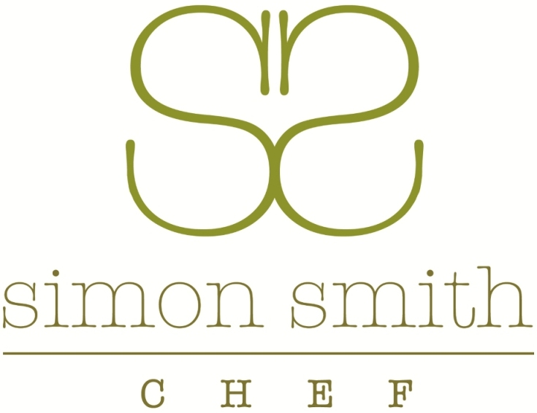

CARVED BUFFET MENU
COLD

HOT ROAST SIRLOIN OF BEEF WITH HORSERADISH AND TARRAGON MUSTARD

VEGETARIAN BUTTERNUT SQUASH ‘WELLINGTON’ WITH FIELD MUSHROOMS

POACHED FILLET OF SALMON WITH A FRESH LIME AND WATERCRESS MAYONNAISE

BREAST OF CHICKEN WITH A LIGHT CURRY MAYONNAISE, SULTANAS AND CORIANDER

SALADS

GIANT COUS-COUS WITH FRESH BASIL AND A TOUCH OF CHILLI

ROAST BUTTERNUT SQUASH, CAULIFLOWER, CELERIAC AND PUMPKIN SEEDS

VIETNAMESE STYLE SALAD WITH BEANSPROUTS, RED ONION, CHILLI AND PICKLED GINGER

CAESAR SALAD WITH ROMAINE LETTUCE, FREE RANGE EGG, FRESH ANCHOVY FILLETS AND SHAVED PARMESAN

CUCUMBER, CELERY AND ALMOND

BREADS AND BUTTER
~~~

SWEETS

DARK BELGIAN CHOCOLATE AND HAZELNUT GANACHE FRESH RASPBERRIES

SUMMER BERRY CHEESECAKE

ETON MESS WITH FRESH STRAWBERRIES

