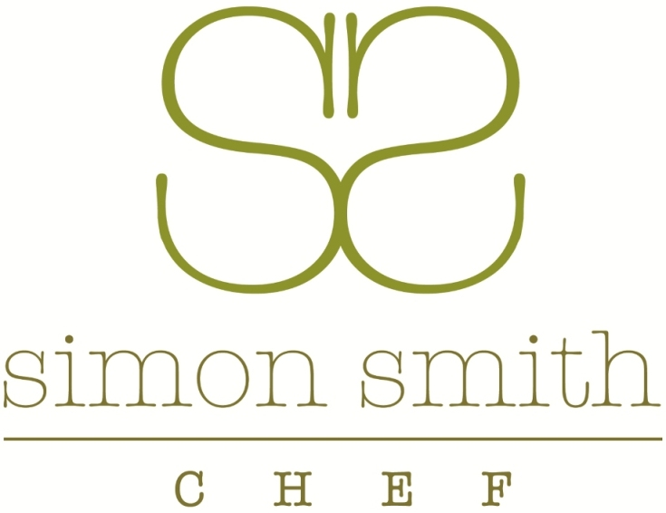

Bronze package canapés @ £19.50 per head

Cherry tomato and Mozzarella pipettes with balsamic and olive oil

Shropshire blue paté rolled in pecan and chive, served in a croustade

Pesto cornet filled with pea and mint purée topped with a quail egg

Honeyed goat’s cheese and spiced beetroot served in a beetroot tart

Smoked salmon, cream cheese and chive on a chilli rice cracker

Bloody Mary jelly with horseradish on a chilli croute

Smoked chicken and lime paté, pomegranate seeds, pastry tartlet

Rosemary and almond shortbread

Cocktail sausage with a grain mustard and tomato glaze

Silver package canapés @ £26 per head

Cherry tomato and Mozzarella pipettes with balsamic and olive oil

Shropshire blue paté rolled in pecan and chive, served in a croustade

Pesto cornet filled with pea and mint purée topped with a quail egg

Honeyed goat’s cheese and spiced beetroot served in a beetroot tart

Vol-au-vent filled with artichoke and truffle purée

Smoked salmon, cream cheese and chive on an oregano croute

Bloody Mary jelly with horseradish on a chilli croute

Rosemary and almond shortbread

Sweet

Chocolate, orange and hazelnut ganache tartlet

Strawberry and meringue Eton mess

Gold package canapés @ £29.50 per head

Cherry tomato and Mozzarella pipettes with balsamic and olive oil

Shropshire blue paté rolled in pecan and chive, served in a croustade

Pesto cornet filled with pea and mint purée topped with a quail egg

Goat’s cheese and beetroot served in a beetroot tart

Smoked salmon, cream cheese and chive on an oregano croute

Hot Canapés

Mini Yorkshire pudding with roast beef

Croque Monsieur with Chorizo sausage

Roquefort and walnut cheese pastries

A selection of mini quiches

Sweet

Strawberries and cream in a strawberry tartlet

Coconut and peppercorn shortbread with mango cream

Warm chocolate and orange brownie

