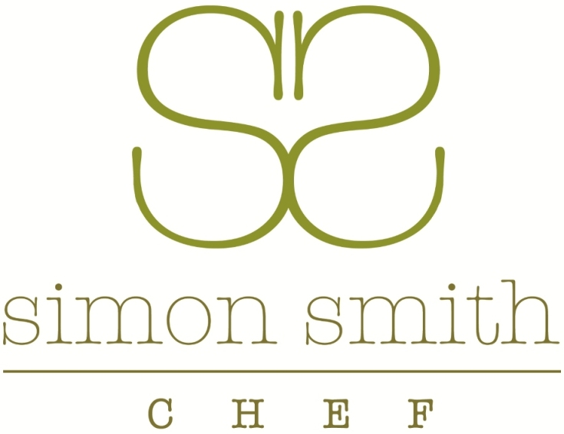

POTATO AND MINT SALAD

CHICKEN SWEETCORN AND TARRAGON SALAD

BEETROOT CURED SALMON WITH GOLD DUST

KING PRWAN WITH M,ARIE ROSE SAUCE

CARROT , CASHEW AND CELERIAC SALAD

CHEESE AND ONION QUICHE

MATURE CHEDDAR, AND PICALLILI WRAP

CHARCUTERIE, PEPPERED BEEF PASTRAMI,,PARMA HAM BRESAOLA, SALAMI

TOMATO, BASIL AND MOZZARELLA SALAD

CHOCOLATE AND ORANGE TART

COCONUT AND CHAMBORD CREAM ÉCLAIR

COFFEE WALNUT CAKE WITH BAILEYS

FRENCH BAGUETTE

